Table of Contents

*Table of figures* 1

Chapter 1 Overview 2

1.1 Introduction to the system 2

1.2 Background of system 2

1.2.1 Problem statement 3

1.3 Justification for project 3

1.4 Overview of purpose system 3

Chapter 2 4

Scope 4

2.1 Aims of the project 4

2.2 Objective of the project 4

2.3 Featured to be included 4

2.4 Overview of the scope 5

Chapter 3 6

Development Methodology 6

3.1 Methodology to be used 6

3.2 Design Pattern 8

3.3 System Architecture 9

Chapter 4 11

Scheduling 11

4.1 Work Breakdown structure 11

4.2 Milestone 13

Description of Milestone 14

4.3 Gantt chart 15

Chapter 5 18

Risk Management 18

Chapter 6 20

Configuration Management 20

Chapter 7 23

Conclusion 23

Reference and Bibliography 24

# *Table of figures*

*Fig 1 Waterfall Model* 7

*Fig 2 Model View Controller* 9

*Fig 3 Three-tier architecture* 10

*Fig 4 Work breakdown structure* 12

*Fig 5 Scheduling* 16

*Fig 6 Gantt Chart* 17

*Fig 7 Project local Directory(1)* 21

*Fig 8 Project Local Directory (2)* 22

*Fig 9 Git Directory*

# Chapter 1 Overview

## 1.1 Introduction to the system

The project Overseas employment training and placement is the manageable web application which provides training for the job and help in every sector where candidate can easily make a life in abroad. We can find different candidate at abroad are lacking job and also having life issues or we can find the loss of amount of candidate due to the wrong overseas involvement so for the reducement of these issues overseas employment training and placement is implemented to solve all the issues and make life more comfortable.

## 1.2 Background of system

As collecting the information, we can find there is no available of any facilities in term of employment training and placement. So, it can be more difficult at particular time to spread the information about its benefit. As work done cannot be convenient to candidate. Here while providing the training candidate may feel uncomfortable or unsatisfied or the providing work facilities can harm on their behavior which hamper the purpose of the application.

The main aim of the application is to serve the people and make their life comfortable in abroad as many mischief behavior or accident has occurred due to lack of proper management system.

## 1.2.1 Problem statement

As looking for the past record of overseas none of them has proper satisfying guidelines or candidate record. Due to this all the candidate has to face unknown identity in the abroad. In case for the sudden details of the candidate the client couldn’t make reports available at proper time. Also, the candidate has to wait over a long period for the acceptance of the record and to visit. This has not only affected people’s life but also affect the business as progress record was also unknown.

## 1.3 Justification for project

In every aspect there is both positive and negative interface. Though this field covers more flaws but once this project is applied in the market and people get used to apply it, it can cover up all the flaws and make people’s life go in manageable path. This will be the flexible project where people won’t have to face problem while using its interface as it will be designed user friendly.

## 1.4 Overview of purpose system

This is completely a new web application in the market due to which at first phase they cannot get used to it. But looking into it beneficial work done it can get good market in future. This project aims to have all the employee at abroad can move safe and have luxury life as it aims to provide job according to their will and provides the insurance or guide their life to the new place in better way. The candidate can get updated with every detail like schedule of interview, new job, foreign exchange, payment update and many more.

# Chapter 2

# Scope

## 2.1 Aims of the project

* To provide the better services for the candidate in job finding, payment, health insurance and many more.
* To record the data of the overview activities of the candidate in training, selection or rejection and payment.
* To maintain the standard of the company in the market and upgrades its success using latest method in overseas.

## 2.2 Objective of the project

As we can find various problem in this field so I have planned to make over the changes in this relative field. The main purpose of this overseas project is to provide the personalized views to both administrator and the candidate. This web application helps in keeping the record in accurate way and reduce the book-writing, files and make the software more user friendly. Also provides reports on training, job selection, insurance, fees payment and pending record and the foreign exchange.

## 2.3 Featured to be included

* Registration
* Training segment
* Interview segment
* Client/Company segment such as details of the no.of client, company, business activities.
* Insurance
* Foreign Exchange
* Training fees
* Report segment such as generates the reports on number of registrations, selection list, rejection list, interview schedule and many more.

## 2.4 Overview of the scope

The project is designed to meet the market and world competition and to make human life easier. As we can find in our daily life challenges are increasing in day to day period. So, I have aim to design overseas employment training and placement by adding various useable features where not only people but the company as well client can also get profit through the project.

# Chapter 3

# Development Methodology

## 3.1 Methodology to be used

For the project I will prefer to use the waterfall methodology as it is simple and quick to operate. Also, the project is small where waterfall model is mostly appropriate.

Waterfall model is the sequential approach to the software development life cycle. It is appropriate for the fixed known requirements, establishment of time management and known technology. It helps in arranging the task in more disciplined way.

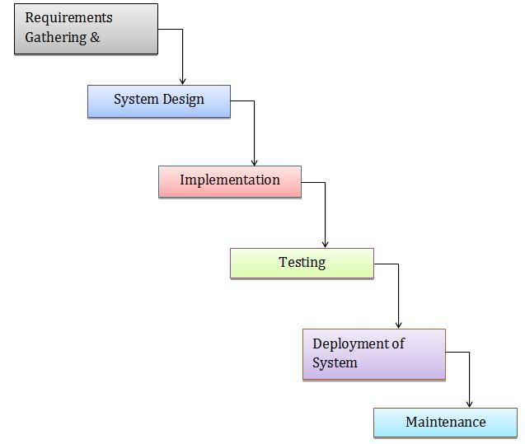

Figure 1 Waterfall Model

## 3.2 Design Pattern

MVC is an architectural pattern which is used in designing, structure of the application and helps in creating interfaces. This design pattern is simple and easy to operate and understand. So I will prefer this design pattern in the application to manage the code and design in standard way. MVC stands for module, view, controller where it separated out into three different way and makes the developer easy to access the code as well it reduces time and complexity. These days many developers implement MVC pattern as it is used in various programming language.

The MVC establish the components that is used in the development. They are

• Module: Module contains the core logic of the program.In the application module represents the logical structure of data and has class of high-level connection.

• View: It represents the information of the system as here information with multiple views is possible. It displays the objects within application and also includes everything that can view by the user.

• Controller: It helps in the communication between model and view as it indicates the classes that can connect the model and view. Controller contains the event handlers which triggers specific methods in the program. Controller helps view communicate with module of the application.

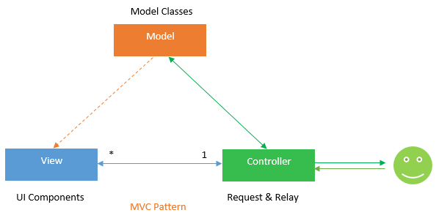

Figure 2 Model View Controller

## 3.3 System Architecture

Here I will use the three-tier architecture as three-tier architecture is a software design pattern and client- server architecture which helps to maintain and develop data storage, data access and user interface as independent modules on separate platforms.

Presentation tier- It is the front-end layer in the 3-tier system helps to display information related to services available on a website. It consists of the user interface. It communicates with other tiers by sending results to the browser and others tiers in network. It displays the content and information useful to an end user.

Application tier- It is also referred as the logic tier, middle tier, business logic as it supports the application core function. This tier is pulled from the presentation tier. It controls application functionality by performing detailed processing

Data tier- It is referred as the storage tier as it consists of a database and a program for managing read and write access to a database. It can be hosted on-premises or in the cloud.

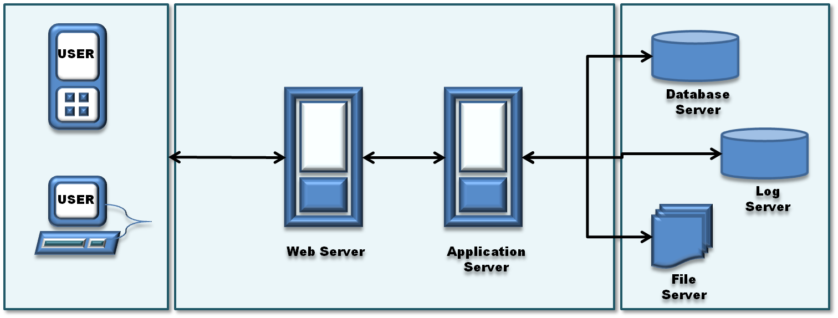

Figure 3 Three-tier architecture

# Chapter 4

# Scheduling

## 4.1 Work Breakdown structure

WBS is a project key which helps in managing sections of the project. It helps to explain the scope into manageable chunks so that the administrators as well team can understand the section as each section of the work has its own importance and definition. The time estimation and budget can be developed easily and quickly by allocating time and cost to specific sections of the WBS. It also helps to quickly identify the risks that occurs during the project.

**Overseas Employment Training and Placement**

**Project**

**Management**

**Document**

**Deployment**

ment

**Testing**

**Coding**

**Design**

**Analysis**

Final project

testing

Structural Model

Requirement gathering

Project Overview, Scope of the project

Unit Testing

Interface coding

Configuration

Use case diagram

Interface design

Database coding

Development methodology

5 t

Integration Testing

Database design

Class diagram

Scheduling

White box testing

Activity diagram

Risk Management

Black box testing

Architecture

Configuration Management

Submission

Figure 4 Work breakdown structure

## 4.2 Milestone

|  |  |
| --- | --- |
| Milestones | Date |
| **Project Management**   * Project Overview, scope of the project * Development Methodology * Scheduling * Risk Management * Configuration Management * Submission | June 16th- July 1st 2019   * June 16th- June 18th 2019 * June 19th- June 21th 2019 * June 22th- June 24th 2019 * June 25th- June 27th 2019 * June 28th- June 30th 2019 * July 1st 2019 |
| **Analysis**   * Requirement gathering * Use case diagram * Class diagram * Activity diagram * Architecture | July 2nd- July 29th 2019   * July 2nd – July 8th 2019 * July 9nd – July 13th 2019 * July 14nd – July 18th 2019 * July 19nd – July 24th 2019 * July 25nd – July 29th 2019 |
| **Design**   * Structural model * Interface design * Database design | July 30th- August 29th 2019   * July 30th- August 9th 2019 * August 10th- August 19th 2019 * August 20th- August 29th 2019 |
| **Coding**   * Interface coding * Database coding | August 30th- September 20th 2019   * August 30th- September 10th 2019 * September 11th- September 20th 2019 |
| **Testing**   * Unit testing * Integration testing * White box testing * Black box testing | September 21th – September 30th 2019   * September 21th – September 22th 2019 * September 23th – September 25th 2019 * September 26th – September 28th 2019 * September 29th – September 30th 2019 |
| **Deployment**   * Testing * Configuration | October 1st - October 9th 2019   * October 1st - October 4th 2019 * October 5st - October 9th 2019 |
| **Document**   * Final project | October 10th - October 12th 2019   * October 10th - October 12th 2019 |

Table: Time estimation of the project

Here all the time estimation is allocated so that project can complete at the given listed time with every possible requirement involved.

### Description of Milestone

* Project Management (16 days)
* Project Overview, scope of the project (3days)
* Development Methodology (3 days)
* Scheduling (3 days)
* Risk Management (3 days)
* Configuration Management (3 days)
* Submission (1 day)
* Analysis (28 days)
* Requirement gathering (7 days)
* Use case diagram (5 days)
* Class diagram (5 days)
* Activity diagram (6 days)
* Architecture (5 days)
* Design (31 days)
* Structural model (11 days)
* Interface design (10 days)
* Database design
* Coding (22 days)
* Interface coding (12 days)
* Database coding (10 days)
* Testing (10 days)
* Unit testing (2 days)
* Integration testing (3 days)
* White box testing (3 days)
* Black box testing (2 days)
* Deployment (9 days)
* Testing (4 days)
* Configuration (5 days)
* Document (3 days)
* Final project (3 days)

## 4.3 Gantt chart

It is commonly used in project as it helps in showing activities and the time estimation. There involves the list of the activities, time scale and days. Here each activity is represented by a bar that is the position and length of bar reflects the start date, duration and end date of the project activity.

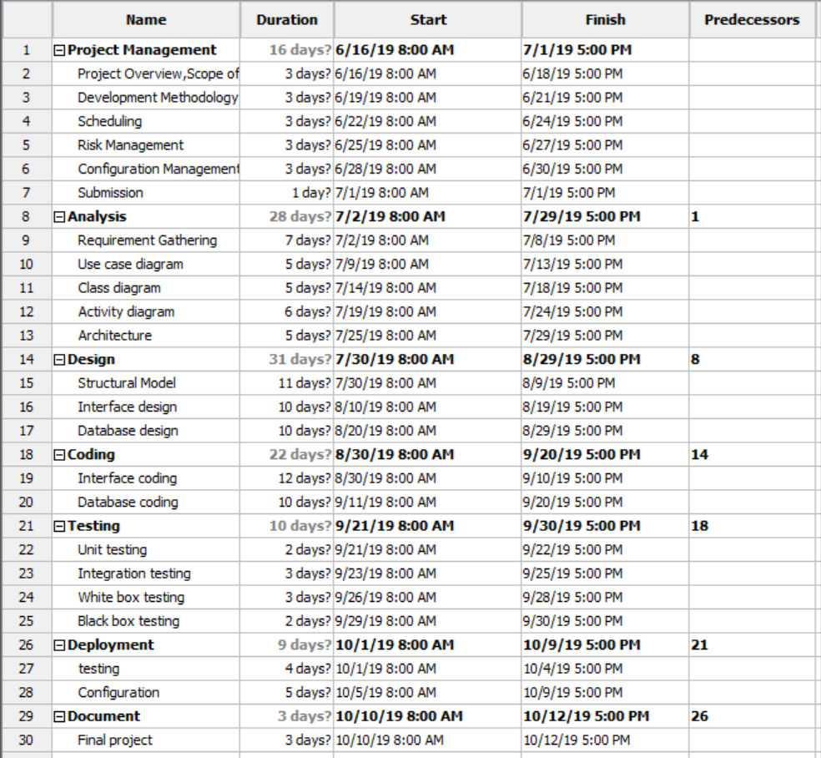

Figure 5 Scheduling

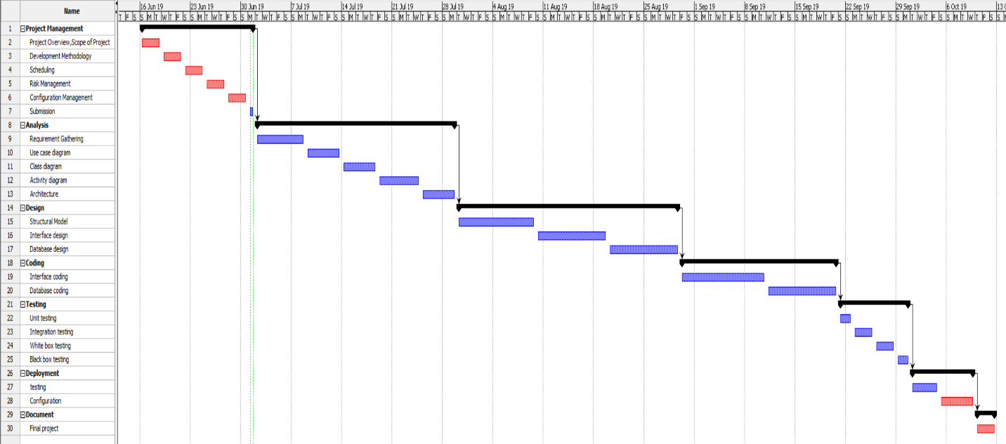

Figure 6 Gantt chart

# Chapter 5

# Risk Management

Risk management helps to identify and control the threats in an organization. Risk can come from sources including financial market, threats from project failure, natural causes and accidents. Risk management identifies a various type of risk that has a 100% probability of occurring but is ignored by the organization due to lack of identification ability.

|  |  |
| --- | --- |
| Likelihood | Value |
| Low | 1 |
| Medium | 2 |
| High | 3 |

Table: Likelihood

|  |  |
| --- | --- |
| Consequences | Value |
| Very low | 1 |
| Low | 2 |
| Medium | 3 |
| High | 4 |
| Very High | 5 |

Table: Consequences

|  |  |  |  |  |  |
| --- | --- | --- | --- | --- | --- |
| Risk id | Risk  Description | Likeli-hood | Conse-quences | Impact | Action |
| 1 | Database Failure | 2 | 4 | High | Backup of the database should be maintained |
| 2 | Power fluctuations | 2 | 4 | High | Power backup must be maintained. |
| 3 | Attack on database | 3 | 4 | High | DMZ zone must e created for servers. |
| 4 | Domain and hosting | 2 | 3 | Medium | Domain and hosting with unlimited bandwidth must be used. |
| 5 | Difficulty on UI | 1 | 2 | Low | In website guidelines are used. |

*Table: Risk Management*

# Chapter 6

# Configuration Management

The configuration management is used to identify and track individual configuration items, documenting functional capabilities and independencies. The developers use configuration management tools to verify the effect a change to one configuration item has on other systems.

For the configuration management backup is created that is Local directory in PC and Git Hub so that data can remain safe.

Folders are created for local backup and each have their subfolders in it.

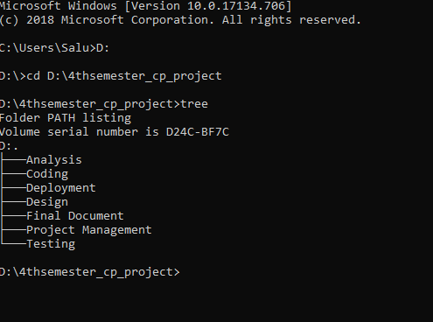

Figure 7 project local directory

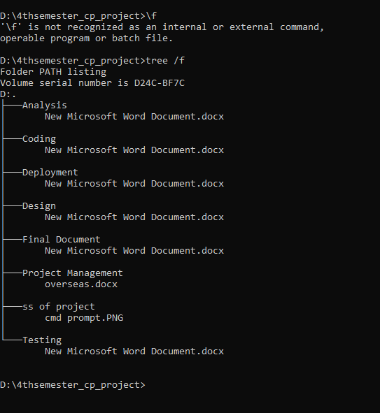

Figure 8 project local directory (2)

# Chapter 7

# Conclusion

Here the project Overseas Employment training and placement is designed adding its features, aims, methodology and design pattern. For the smooth work done the time calculation is estimated separating out the special section of the activities. The risk management is also added to identify and control the threats.

# Reference and Bibliography

#### **Waterfall Model: What Is It and When Should You Use It?**

**In-text:** (Powell-Morse, 2019)

**Your Bibliography:** Powell-Morse, A. (2019). *Waterfall Model: What Is It and When Should You Use It?*. [online] Airbrake Blog. Available at: https://airbrake.io/blog/sdlc/waterfall-model [Accessed 1 Jul. 2019].

What is risk management? - Definition from WhatIs.com

**In-text:** (SearchCompliance, 2019)

**Your Bibliography:** SearchCompliance. (2019). *What is risk management? - Definition from WhatIs.com*. [online] Available at: https://searchcompliance.techtarget.com/definition/risk-management [Accessed 1 Jul. 2019].

What is configuration management (CM)? - Definition from WhatIs.com

**In-text:** (SearchITOperations, 2019)

**Your Bibliography:** SearchITOperations. (2019). *What is configuration management (CM)? - Definition from WhatIs.com*. [online] Available at: https://searchitoperations.techtarget.com/definition/configuration-management-CM [Accessed 1 Jul. 2019].